# No Game School

## Description

BGod is a college student who love computer games, but unfortunately his school just published a rule that Games should disappear in the campus , that means nobody can play computer games in school, including the students dormitory. However, the student don’t take it seriously, that’s why the manager of the school gets so angry that he decided to go to the dormitory to punish the students. You should know the manager any punish those students who **is playing** games at the moment he enter the room, and leave **immediately** if nobody is playing game in this room.

BGod is a talented game player , in fact, he is the Carry of a famous Gaming club, so he needs time to practice he’s skills . And luckily , BGod’s roommate PY is a Geek(also a BGod fan), he hacked the manager’s computer and get the timetable of the manager, and tell BGod when will the manager come to their room tomorrow. A big E-sport Event is around the corner, so BGod list m skills he should practice, each skill takes some time to practice and improve BGod’s skill by some points. You should calculate the max total improvement points BGod can get. Note any skills can be practiced any times , including 0.

## Input

The first line contains a integer T ( T <= 10 ), then T cases follows.

In each case, there are 3 parts of input.

The first part contains 3 integers L, n, m in a single line.Range[0, L] is the time BGod decide to practice , n is the times manager would enter his room, m indicate the total number of the skills.

The second part contains n integers ti(0 <= ti <= L) in a single line, means the manager would enter his room at ti. Note that ti is giving in the increasing order.

The third part has m lines , each line contains two integers ci, vi, means this skill needs ci minutes to practice and can make vi points improvement.

L <= 500

n <= 10

m <= 100

## Output

For each case, you should output the max points BGod can improve.

## Sample

|  |  |
| --- | --- |
| **Input** | **Output** |
| 2  6 1 3  3  2 3  2 4  2 5  6 2 3  2 4  2 3  2 4  2 5 | 10  15 |

## Hind

Note that BGod will be catch playing games any in the interval of his practicing, excluded the beginning and the ending of each practice time.

Sample 1:

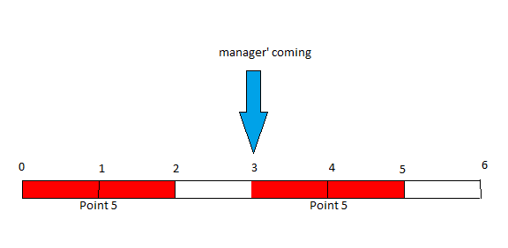

Sample 2:

